**Caribbean Corn Soup**

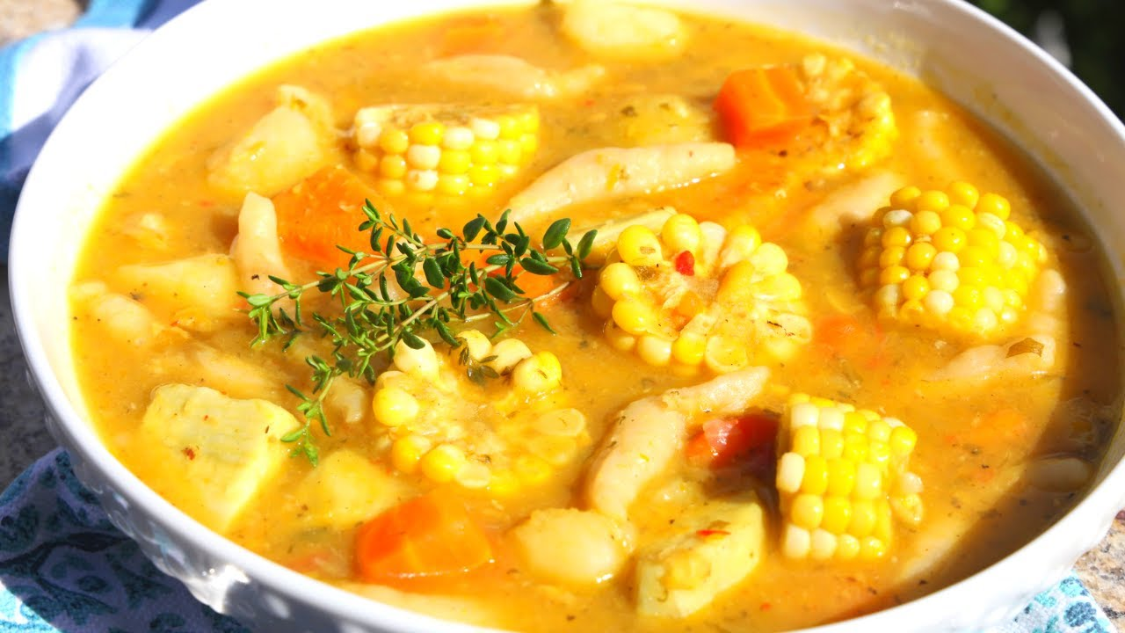

**INGREDIENTS**

1.5 lb Salted Pigtails cut into pieces

1 1/4 cups Yellow Split Peas , washed

5 1/4 cups Water

4 cloves Garlic , crushed

2 Tbsp Coconut Oil

6 sprigs Fresh Thyme

1 Large Onion , diced

2 stalks Celery , diced

1/4 cup Chopped Fresh Parsley

1 bunch Scallions , chopped

3 scallions per 6 servings

3 Pimiento Peppers , diced

2 Red Bird's Eye Chili Pepper

3 Tbsp Chopped Culantro Leaves

1/4 tsp Freshly Ground Black Pepper

2 cups Diced Pumpkins

2 cups Diced Sweet Potatoes

2 cups Chicken Stock

1 1/2 cups Coconut Milk

2 Carrots , diced

4 Corn cut into pieces

14.75 ounces Creamed Corn

1 cup Frozen Corn Kernels

1 cup All-Purpose Flour

1 pinch Salt

**METHOD**

1. Wash the pieces of Salted Pigtails (1.5 lb) , then place in a deep pot covered in water and bring to a boil. Reduce to a rolling boil and cook for about 25 minutes. This step will to tenderize the pigtails and to remove some of the salt it was cured in.
2. After 25 minutes, drain and add 5 cups of Water (5 cups) to the pot, along with the Yellow Split Peas (1 1/4 cups) and Garlic (4 cloves) and bring to a boil. Reduce to a simmer and cook for 35-40 minutes or until the peas are tender.
3. Meanwhile in a large soup pot, heat the Coconut Oil (2 Tbsp) over a medium flame, then add the Onion (1) , Scallions (1 bunch) , Fresh Thyme (6 sprigs) , Pimiento Peppers (3) , Culantro Leaves (3 Tbsp) , Fresh Parsley (1/4 cup) , Red Bird's Eye Chili Pepper (2) , Celery (2 stalks) , and Freshly Ground Black Pepper (1/4 tsp) . Turn the heat to low, stir well and cook for about 4-5 minutes.
4. Next up you can add the Sweet Potatoes (2 cups), Pumpkins (2 cups) , and Carrots (2) and stir well. Then add the Chicken Stock (2 cups) and bring to a boil and cook for about 25 minutes.
5. By now the peas/pigtail should be ready. Add it to the soup pot, be gentle, and stir well. Add the Coconut Milk (1 1/2 cups) , Frozen Corn Kernels (1 cup) , and Creamed Corn (1 can) . Bring everything to a boil, reduce to a simmer and allow cooking for another 20 minutes.
6. After 20 minutes, you may use a swizzle stick or a whisk to break the pumpkin, carrot and sweet potato down. The soup will go very thick at this point, so add some more stock or water if you feel it needs it. As it cooks, you should work on the dumplings.
7. Place the Water (1/4 cup) , All-Purpose Flour (1 cup) and if you want, Salt (1 pinch) in a bowl and knead to form a soft dough. Add water as necessary, and then let the dough rest for about 5 minutes.
8. Divide into 3 smaller balls and roil each part out to form a thick straw, cylinder. Cut that into bite-size pieces, about 1/2-inch, and add to the boiling soup.
9. You may also add the cut pieces of Corn (4) now. Cook for about 5 minutes after adding the dumplings and corn of the cob. Taste for salt and adjust accordingly, then serve.